2022 & 2023 LARGE ENSEMBLE SUPERIOR AWARD
Order Form
Mail to: NSAA, 500 Charleston Street – Suite #1, Lincoln, NE 68508-1119

The Nebraska School Activities Association provides a ribbon/medallion, with a pin attachment to individual members of Large Ensembles that receive a Superior rating from all three judges. The medallions will be stamped on the back and look like (sample below).
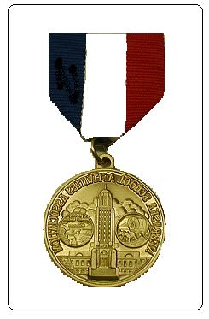
Superior
District Music
(ensemble)
(year)

Please use this form to order medallions. A separate order form must be completed for each Large Ensemble. Orders will not be taken by telephone. Schools must place one order for all medallions and payment must accompany the order. We will not ship to individuals. The cost is $2.50 per medallion.

Large Ensemble Categories—(Please circle one.)
Mens/Womens

Band Mixed Chorus Madrigal/Chamber Choir Show Choir Orchestra Chorus Jazz Band Jazz Choir

Year

School __________ Need medallions by: (list specific date)

Total Number of Medallions
Total Medallion Cost ($2.50 x No. Ordered) | $
Shipping Costs:  1 Medallion----------------$2.00  2-4 Medallions------------$4.00  5-7 Medallions------------$6.00  8-50 Medallions-----------$8.00  51-100 Medallions--------$10.00  101-150 Medallions------$12.00  151 & over Medallions--$14.00 | $
Total Payment Enclosed | $

FULL PAYMENT MUST BE INCLUDED WITH YOUR ORDER.
No medallions will be ordered until payment is received. No purchase orders accepted for medallions.

Order Authorized by:
Signature Position

Ship To:
Name Position

Mailing Address

City State Zip

